Jared Jones
626001380
CSCE 313-508
PA 5 Report
This programming assignment uses the original PA 3 working code and instead of implementing it using FIFO pipes, the serverTCP and clientTCP code was taken and combined with the already working code in order to make the PA3 program able to communicate over the internet and between computers. The dataserver program takes in a port on which it will listen for incoming client commands, and then the client command takes in a ip address and a port so that it knows which computer and port the dataserver is located on it so that it can communicate. This program is able to run with all of the same constraints of the previous program being able to use > 500 threads and also having a buffer size that is not bound and based on the n value.
For the data requests, the number of worker threads and size of buffer were analyzed and graphs were created based off of varying those inputs.
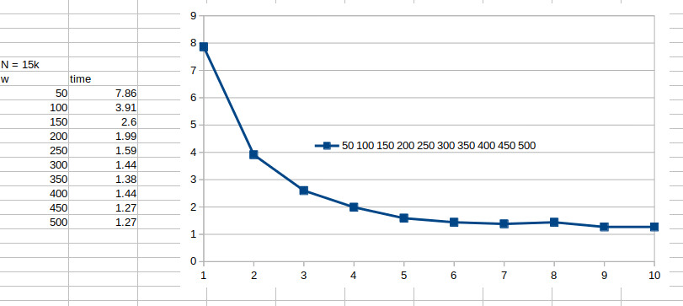
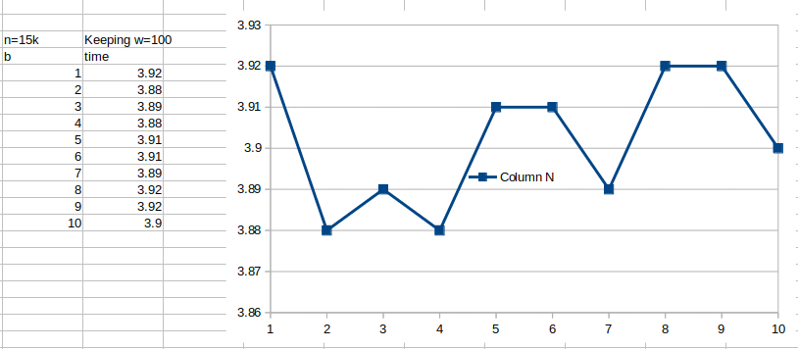
The above graph represents what occurs when varying the number of worker threads. This shows how increasing workers can significantly decrease speed up to a point. There is a logarithmic relationship between run-time and number of workers. This is caused because after enough worker threads are created, there are diminished returns with respect to the amount of work each additional thread will do. Each thread does less work and takes longer to get set up and just ends up waiting on all the other threads to push and pop from the buffer. This causes the diminished returns.

When varying the size of the bounded buffer, not much of a change in run-time is observed because the size of the buffer is not the slowest/ limiting factor of the program. The slowest part is the worker threads, because they have to run and communicate with the dataserver and be thread safe, which causes them to take longer to run so they are never really waiting on the buffer to supply a request, the buffer is always waiting for the worker threads to remove a command so the patient threads can refill the buffer.
If a file name is included in the command line arguments, one patient thread will fill a request buffer with commands to copy all of the binary and create a file that is called “y” + original_file_name that will be stored in the received folder. When varying the number of worker threads while running a file transfer, there is a observable benefit from increasing the number of worker threads up to a certain threshold this can be seen below.
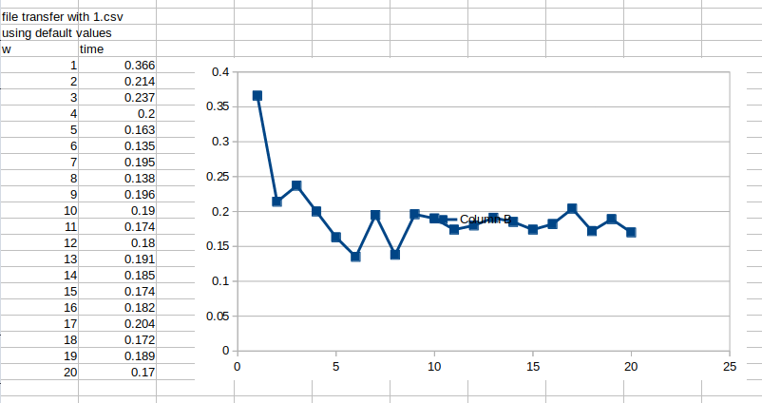
For the first three additional worker threads there is a great decrease in run-time caused by more threads being able to work on the worker functions reducing the overall load of the program. After a certain number of threads are added the threads stop decreasing the run time and start having negative repercussions due to the extra work the client will have to do to construct each thread and the more threads there are, the more waiting each thread has to do. This leads to the slow increase in run-time after the sharp decrease seen in the first couple of worker threads.

